Saint Patrick’s Church
Year of Sacraments
July 2020 - June 2021

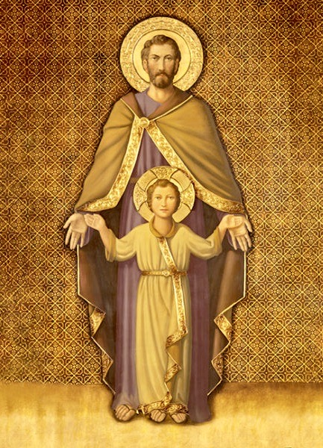

“With a father’s heart:
That is how Joseph loved Jesus…”
- Pope Francis, Apostolic Letter, Patris Corde

Year of Saint Joseph
December 8, 2020 – December 8, 2021
Dear parishioners,

Christ is the Way!

We have waited until this weekend after March 19, the Solemnity of Saint Joseph, Husband of the Blessed Virgin Mary, to launch the Year of Saint Joseph in our parish. This is not to minimize the importance of Saint Joseph but that we may render him due attention since we as a parish have also been celebrating a Year of the Sacraments since July 2021.

I pray that this simple parish guide may provide our families concrete ideas on how to honor Saint Joseph, the Protector of the Universal Church, in this year dedicated to him by our Holy Father, Pope Francis. Do pray to Saint Joseph to lead you to places and activities that will allow you and your loved ones to know him better and grow closer to him.

During this time, please join me in entrusting our parish and our families to both Saint Patrick and Saint Joseph.

God bless you and your loved ones.

In Christ,

Father Edison

Prayer of Consecration to Saint Joseph

O Glorious Patriarch and Patron of the Church! O Virgin Spouse of the Virgin Mother of God! O Guardian and Virginal Father of the Word Incarnate! In the presence of Jesus and Mary, I choose you this day to be my father, my guardian, and my protector.

O great Saint Joseph, whom God has made the Head of the Holy Family, accept me, I beseech you, though utterly unworthy, to be a member of your “Holy House.” Present me to your Immaculate Spouse; ask her also to adopt me as her child. With her, pray that I may constantly think of Jesus, and serve him faithfully to the end of my life. O Terror of Demons, increase in me virtue, protect me from the evil one, and help me not to offend God in any way.

O my Spiritual Father, I hereby consecrate myself to you. In faithful imitation of Jesus and Mary, I place myself and all my concerns under your care and protection. To you, after Jesus and Mary, I consecrate my body and soul, with all their faculties, my spiritual growth, my home, and all my affairs and undertakings.

Forsake me not, but adopt me as a servant and child of the Holy Family. Watch over me at all times, but especially at the hour of my death. Console and strengthen me with the presence of Jesus and Mary so that, with you, I may praise and adore the Holy Trinity for all eternity. Amen.

How to Celebrate this Sacred Time

- Begin by consecrating yourself and your family to Saint Joseph, that he may lead you closer to God. Consecration means entrusting yourself and your loved ones to his protective care: making Saint Joseph your spiritual father, and seeking to become like him. Do the consecration by praying the Prayer of Consecration above.

- Visit and explore the wonderful website by the Diocese of Charlotte: https://yearofstjoseph.org for various resources like –
  - Why Honor Saint Joseph?
  - Get to Know Saint Joseph
    - Learn the Litany of Saint Joseph
    - Learn the Virtues of Saint Joseph
    - Learn the Year of Saint Joseph Prayer, and recite it after praying the Rosary of the Blessed Virgin Mother
  - How to Consecrate Yourself to Saint Joseph

- Plan a pilgrimage to one or more of the Saint Joseph churches in our diocese. Do call the churches to ask about the hours for visiting. As you make your holy visit, pray the Prayer of Consecration before the image of Saint Joseph.
  - Saint Joseph on 43 Gebhardt Road, Penfield, NY; (585) 586-8089
  - Saint Joseph on 6105 Rush-Lima Road, Rush NY; (585) 334-3518
  - Saint Joseph on 114 Sodus Street, Clyde NY; (315) 902-4130
  - Saint Joseph on 8831 S. Seneca Street, Weedsport NY; (315) 252-9545
  - Saint Joseph on 206 Fremont Street, Wayland NY; (585) 728-2228
  - Saint Joseph on 8508 Campbell Street, Campbell NY; (607) 359-2115
  - And if you find yourself in Montreal, Canada, consider visiting the beautiful Oratory of Saint Joseph.

- Avail yourself and your family of the Year of Saint Joseph Indulgences:
  - Meditate for at least 30 minutes on the Our Father.
  - Participate in a spiritual retreat of at least one day that includes a meditation on Saint Joseph.
  - Perform a corporal or spiritual work of mercy.
  - Recite the Holy Rosary in families, and between the husband and wife.
  - Entrust your work daily to the protection of Saint Joseph and to all believers who invoke with their prayers the intercession of the Wonder Worker of Nazareth.
  - Pray the Litany of Saint Joseph, or some other prayer to Saint Joseph, typical of the other liturgical traditions, for the persecuted Church and for the relief of all persecuted Christians.
  - Pray any lawfully approved prayer or act of piety in honor of Saint Joseph especially on:
    - March 19th (Solemnity of St. Joseph)
    - May 1st (Feast of St. Joseph the Worker)
    - December 26th (Feast of the Holy Family)
    - The 19th day of every month
    - Every Wednesday (a day dedicated to the memory of the Saint according to the Latin tradition)
  - The gift of plenary indulgence extends particularly to —
    - The elderly, the sick, the dying, and all those who for legitimate reasons cannot leave their home.

