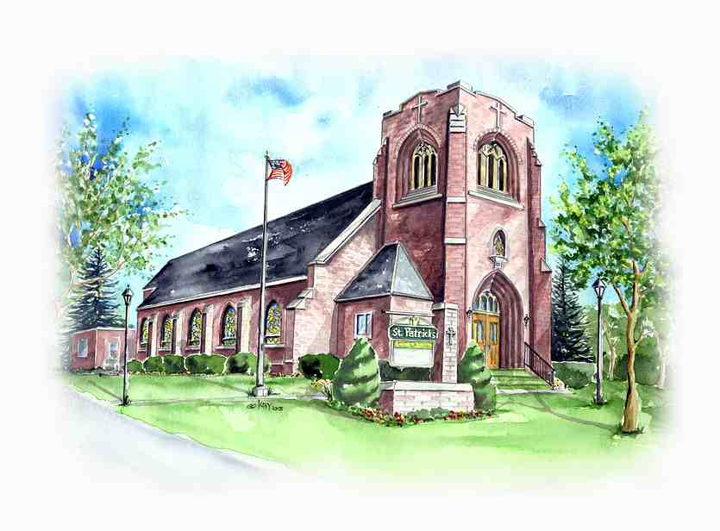
Saint Patrick’s Church
115 Maple Avenue
Victor, NY 14564
(585) 924-7111
www.stpatricksvictor.org

March 10, 2021
Wednesday of the Third Sunday of Lent

Dear parishioners,

Christ is the Way!

This past weekend, I noticed some families who are back, in-person, to the celebration of the Sunday Mass. Thanks be to God! Also, other parishioners who have received the COVID vaccine are expressing their intention to return to in-person celebration of the Mass.

For these, I ask every household to be attentive to the Sign-Up Procedures for the Weekend Masses and other parish events. The sign-up is done for two reasons: (i) so that parishioners know available seating capacity, and (ii) so that we have a tracking system, in case, we need to communicate with you.

Here are some practical tips for the Sign-Up Procedure:

- We use Sign-Up Genius. The link is also found on our parish website.
- It is a good habit to sign-up for the Sunday Mass early during the week.
- If you observe our current in-person attendance, the Sunday 8:30 AM Mass is the most attended of the four weekend Masses. Also, the size of the groups who sign-up at this Mass tend to be one to two per group. Therefore, when we reach 100 signees, the church is full capacity. Note: When the sign-ups at the 8:30 AM Mass has reached 100, we will not be accepting walk-ins. Due to fire code and the current social distancing regulation, we cannot set chairs on the aisles. Also, the front vestibule is often used by parents, when small children need to move about.
- For parishioners who need low-gluten host, when you sign-up, please include as note the number of hosts you need, e.g. “one low-gluten host”.

Please continue to pray for the end of this pandemic, and continue to promote the safety and good health of all. God bless you.

Father Edison

